Python Setup for Mac
Please complete the setup before the class (Jan 25 2022)

Install Miniconda
Download miniconda installation from https://docs.conda.io/en/latest/miniconda.html

Open a terminal and follow the installation instructions
https://docs.conda.io/projects/conda/en/latest/user-guide/install/macos.html#installing-on-macos

Once you have completed the installation, close the terminal and open a new terminal. You should see ‘(base)’ in your command prompt. You can now proceed to the next section.

Virtual Environment Setup
Conda allow you to partition your application into different environment; this is to ensure that Python applications do not ‘interfere’ with each other; eg. applications using different versions of the same library

On your Mac open a terminal.

Create a new environment
conda create --name myenv

where myenv is the name of your environment. Feel free to use any name. You can create multiple environment

Note: You can confirm the newly created environment, by listing all envs
conda env list

Activate your environment
Once you have created your environment, you will need to activate it
conda activate myenv

Your command prompt will now include the environment’s name.

Exit from your environment
To exit from your Conda environment type the following command
conda deactivate

Installing packages into your environment
You will now need to install Python packages into your environment. Before installation, activate your environment; this step is important!.

These are the list of packages will will be installing into the environment
- numpy
- matplotlib
- tqdm
- gym
- pyglet

On your terminal, type the following command (activate your environment before installing these packages)
conda install numpy matplotlib tqdm pip
pip install gym pyglet

Follow the installation instructions.

Install Visual Studio Code
Download and install Visual Studio Code (VSC); see instructions from the following page

https://code.visualstudio.com/docs/setup/mac

After you have installed VSC, launch it. Next, we need to install the Python Extension for VSC. Open the extension panel by clicking on this icon 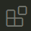 on the menu along VSC’s left window edge. Type Python on the extension window and select the Microsoft Python Extension. See the following image

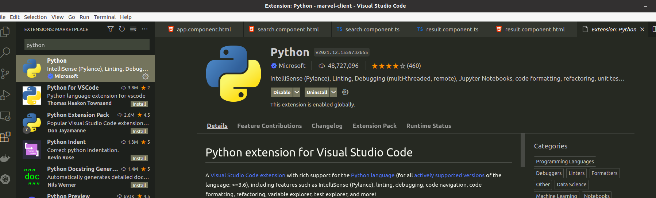

Click on Install to install the extension. After installing the extension, restart VSC. See Visual Studio Code and the Python Extension;

If you like to try out VSC, see following

https://code.visualstudio.com/docs/python/python-tutorial

Slack Channel
I have set up a Slack channel for this workshop. You can use this channel to ask questions. I will also be using this channel to post materials and references. You can use your school or private email to join

https://join.slack.com/t/sst-2022/shared_invite/zt-121qnjzb4-wqgnE5DbWvpkJf8qbyTbHQ

Joining the channel is optional.

Further Reading
For more information on Conda, see the following documents on working with Conda
- Getting started with Conda
- Virtual Environments

